

**Prairie**

**View**

**A&M**

**University**

**PV Settle**

*Prepared by*

**Team 2 -Mavericks:**

George Ekechukwu

Chinagolum Osasah

Pratyush Srivastava

Oluwayemisi Alabi

A Project Submitted in

Partial Fulfillment of the Requirements for

CINS 5338 – Software Project Management

DEPARTMENT OF COMPUTER SCIENCE

ROY G. PERRY COLLEGE OF ENGINEERING

PRAIRIE VIEW A&M UNIVERSITY

Fall 2023

ABSTRACT

International students face many challenges when adjusting to a new nation and culture and have numerous difficulties, particularly in the social and academic domains. This technical report explores the difficulties faced by newly enrolled international students at Prairie View A&M University (PVAMU) and presents a solution called PV Settle that aims to address these challenges by creating a welcoming and supportive environment that facilitates a smoother transition for international students. PV Settle is an intuitive community-driven web application designed to support international students in their transition by providing an integrated platform that connects them to the PVAMU community. The application offers a range of features that provides useful information about the day-to-day needs of international students. This includes aggregated selection of accommodation rental options, features to help students connect with each other, including chat rooms, discussion forums, a prioritized list of tasks designed to facilitate seamless integration, and innovative transportation solutions within the PV community. The application has the potential to make a significant difference in the lives of international students at Prairie View A&M University by helping them to adjust to their new surroundings and to succeed in their academic and social endeavors.

Table of Contents

ABSTRACT 2

CHAPTER 1 3

INTRODUCTION 4

1.2 Problem Statement 4

1.3 Project Goal 4

1.4 Project Objectives 5

1.5 Team Members and Primary Task Assignments 5

CHAPTER 2 7

SURVEY OF EXISTING WORK 7

CHAPTER 3 9

SYSTEM REQUIREMENTS 9

3.1 Functional Requirements 9

3. 2 Use Case Diagram 10

3.3 Catalog of User Stories 11

3.4 Non-Functional Requirements 26

Chapter 4 27

Development Environment – hardware & software 27

4.1 Development Environment: 27

4.2 Additional Support Software: 27

4.3 Programming Languages: 28

Chapter 5 29

SYSTEM DESIGN 29

Database Design 30

UI Design 31

SEQUENCE DIAGRAM 32

Conclusion and Future Work 36

# CHAPTER 1

## INTRODUCTION

**1.1** Background

A significant and increasing percentage of Prairie View A&M University's students consists of international students. These students, who represent a wide range of nations and cultures, enrich the university community in tangible ways with their rich diversity and life experiences. However, international students also face major hurdles transitioning and adjusting to a new country and culture as well as the school's academic and social system facing problems like: lack of access to lodging options before leaving their home country, inadequate knowledge about campus transportation infrastructure and insufficient knowledge or access to information about important activities such as opening bank accounts, obtaining social security number (SSN), best suited phone plans for students, etc. These challenges have the potential to significantly impact their initial experiences settling in, making it more difficult to integrate into the university community. There have been instances of passive aggression to students temporarily squatting with friends and colleagues.

1.2 Problem Statement

The lack of a comprehensive support system tailored specifically to meet the needs of international students is a critical challenge in the PVAMU academic community. This is further worsened by the absence of readily available and relevant information, which makes their transition into university life unnecessarily difficult making these students more likely to experience social problems, such as isolation, stress and loneliness. Even though there’s no easy solution to addressing this complex problem, there is a pressing-need for an efficient, intuitive and user-friendly solution that can bridge the information gap and provide timely information that is all-encompassing about everyday essentials and lifestyle adjustments. The solution developed to tackle this should feature insights into appropriate housing possibilities, simplification of tasks related to essential documents like social security numbers and bank account creation, and real-time information on transportation solutions within the PVAMU community.

Addressing this problem to meet the unique problems of international students is imperative to foster a more inclusive and supportive environment.

1.3 Project Goal

The goal of this project is to improve the transition and integration experience of new international students in PVAMU by creating an intuitive, user-friendly solution that provides them with a comprehensive and accessible source of information and support. The solution aims to bridge the information gap by providing an all-in-one platform for

1.4 Project Objectives

The project goals will be implemented by implementing the following objectives.

***Develop a Responsive Web-based Application*** - Creation and development of PV Settle web application to be responsive, intuitive and user-friendly making it easy to access on mobile and web ensuring ease of navigation and accessibility for international students.

***Provision of Comprehensive Innovation Hub*** - Timely and relevant information offering insights and step by step guides on essential tasks such as opening bank accounts and creating a social security number will be present to guide international students in transitioning.

***Creation of Community Driven Engagement*** - Provide active platforms for engagement where international students can connect and share their experiences to foster resource-sharing and assistance, eliminating the sense of isolation that new students may feel.

***Facilitation of Seamless Mobility and Transportation*** - Create a transportation platform that provides international students with affordable, reliable, and accessible transportation options with the ability to schedule and track transportation for seamless movement.

1.5 Team Members and Primary Task Assignments

The team is comprised of four members assigned with the following tasks and responsibilities:

|  |  |  |  |
| --- | --- | --- | --- |
| **S/N** | **Team Member** | **Designation** | **Expertise** |
| 1 | George Ekechukwu | Scrum Master | Problem Solving, SQL, C++, PHP  Communication Skills, Python, |
| 2 | Pratyush Srivastava | Backend Developer | Python, HTML, CSS, SQL, PHP, C++, Security |
| 3 | Oluwayemisi Alabi | Frontend and UI Designer | HTML, CSS, UI/UX, Prototyping, Product Management |
| 4 | Chinagolum Osasah | Product Manager | Product Management, C++, Backlog Refinement, Creation of User-Stories |

# CHAPTER 2

## SURVEY OF EXISTING WORK

We looked at an existing work from Cal Poly Pomona, officially known as California State Polytechnic University, Pomona, a public polytechnic university in Pomona, California. Cal Poly Pomona has a portal called MyCPP (My Cal Poly Pomona), which serves as the gateway to campus online services, and a portal called Bronco Resource Hub, which connects incoming CPP students with the resources and information they need to begin to be acquainted with campus.

Compared to PV Settle at Prairie View A&M University, Cal Poly Pomona offers various resources for international students, but PV Settle provides a more integrated platform. Each university has its unique approach to supporting its international student community.

**Key finding between Cal Poly Pomona and PV Settle**

**Integrated task checklist and progress tracker**: PV Settle provides an organized task checklist and a way to track progress, showing the steps taken and the steps students need to take. This feature helps limit the possibility of students overlooking crucial actions. While Cal Poly Pomona offers various resources, it does not have an integrated task checklist and progress tracker.

**Consolidated academic section**: PV Settle offers an integrated academic section on the website that connects to Prairie View A&M University systems for course registration, class schedules, grades, bill payments, etc. Cal Poly Pomona also provides these services, but they are separate on a single platform.

**Centralized accommodation portal**: PV Settle offers a centralized accommodation portal that aggregates housing options (rental listings) near campus and allows students to compare options. Cal Poly Pomona also has a housing section, but it does not provide the same level of detail as PV Settle's centralized housing hub.

**Interactive map feature and transportation information section**: PV Settle develops an interactive map feature and transportation information section on the website covering ride-sharing services and campus shuttles. Cal Poly Pomona also has a transportation section, but it does not include an interactive map.

**Comprehensive information hub**: PV Settle has an "Information hub" on the website that captures comprehensive information, e.g., obtaining your Social Security Number, opening a bank account, obtaining a driver's license, etc. Cal Poly Pomona provides information for obtaining a Social Security Number, but it is as easily accessible as the Info Center on PV Settle.

**Community Hub** - Both PV Settle and Cal Poly Pomona offer a community hub for their students. PV Settle's community hub is integrated into the platform and provides a centralized location for international students to interact and access all necessary resources. On the other hand, Cal Poly Pomona's community hub, Bronco Resource Hub, is a separate website that connects incoming CPP students with the resources and information they need to begin to be acquainted with campus.

While both universities provide resources to assist international students, PV Settle at Prairie View A&M University offers a more integrated and comprehensive platform. PV Settle's integrated task checklist and progress tracker consolidated academic section, centralized accommodation portal, interactive map feature, transportation information section, comprehensive information center, and community hub all make it easier for international students to transition to life in the United States.

# CHAPTER 3

## SYSTEM REQUIREMENTS

3.1 Functional Requirements

The functional Requirements for PV Settle include;

* **User Registration and Profiles**: This functionality will allow users to create personal accounts within the system. They can provide relevant information, such as personal details, nationality, interests, hobbies, etc., stored in user profiles. This feature enables personalized interactions, task tracking, and access to the platform's resources based on their individual needs.
* **Task Checklist and Progress Tracker**: This gives users a structured list of actions or tasks they must complete during their university transition. It enables users to mark tasks as completed and track their progress, ensuring they don't overlook crucial steps and allowing for a smoother adjustment to academic and social systems. This functionality enhances the user experience by effectively helping international students manage and monitor their transition process.
* **Housing Portal:** This is a centralized portal where international students can search for and compare housing options near their university campus. It simplifies finding suitable accommodation, making it easier for students to secure lodging during their studies.
* **Transportation Hub**: This will offer users essential information, such as shuttle times and locations, allowing students to request shuttle services, including booking rides to the airport, etc. It will also have an interactive map feature that displays bus routes and locations, helping users navigate the campus and find transportation services easily. This multifunctional tool streamlines transportation within the university and its vicinity, enhancing students' convenience and mobility.
* **Academic System Integration**: This will allow for seamless connection with Prairie View A&M University's academic portal, enabling users to perform tasks like course registration, checking class schedules, viewing grades, and making bill payments directly through the platform for a more streamlined and efficient academic experience.
* **Information Hub**: This is a dedicated section within the platform that offers a comprehensive repository of essential information and resources, aiding international students in seamless integration into university life. It covers critical topics such as obtaining a Social Security number, opening a bank account, and obtaining a driver's license, ensuring students have access to crucial guidance and support.
* **Community Hub**: This functionality allows international students to connect with individuals from their country, facilitating the creation of nationality-based groups and providing a discussion forum for students to engage in conversations, share experiences, and build a sense of community.
* **FAQ Section**: It answers frequently asked questions, offering quick and accessible solutions to common queries, enhancing the user experience, and reducing the need for direct support.
* **User Support and Helpdesk**: This section will integrate the existing international services help desk to users to seek assistance, ask questions, and report issues. It offers various support channels, such as chat, email, or a support forum, to ensure users can easily access help and resolve any platform-related concerns promptly.

3. 2 Use Case Diagram

This diagram offers a comprehensive overview of how international students fulfill essential tasks, from onboarding to academic support, fostering a seamless and user-centric experience.

*Fig 1: Use Case Diagram for PV Settle*

3.3 Catalog of User Stories

This collection of user-driven narratives encapsulates the diverse needs of international students. From creating an engaging landing page to connecting with peers and seeking academic guidance, these stories paint a vivid picture of the user experience journey, ensuring a seamless transition into university life.

|  |  |  |  |
| --- | --- | --- | --- |
| Epic | User Story |  | Sprint |
| **Create an engaging, user-friendly landing page to effectively onboard international students to the PV Settle website.** | **As an** international student accessing the website, **I want** an easy-to-navigate landing page interface **so that** I can quickly find the information I need when first visiting the site. | · The landing page shall have user-friendly menus for quick access to essential sections | 1 |
| **As an** international student, **I want** a simple, intuitive navigation menu on the landing page **so that** I can quickly access the most important pages and find what I need efficiently. | · Users should efficiently find the information they need. | 1 |
| **As an** international student, **I want** the key sections and calls-to-action to be clearly visible on the landing page **so that** I know what actions I need to take when visiting the site and quickly find the most relevant information. | · Ensure clear visibility of key sections and calls-to-action on the landing page. | 1 |
| **As an** international student, **I want** the landing page layout to feel welcoming and inclusive **so that** I am eager to sign up and engage with the platform, feeling like it is designed for students like me. | · Create a welcoming, inclusive landing page layout that encourages international students to sign up and engage with the platform | 1 |
| **Develop modular, containerized components to facilitate flexibility and reusability on the PV Settle website** | **As an** international student, **I want** fast loading website pages **so that** I can use the site smoothly without interruption and quickly find what I need. | · Website pages shall load quickly to provide a smooth, uninterrupted user experience. | 1 |
| **As an** international student, **I want** the website layout and menu to be consistent even when new content is added, **so that** I don't get confused while surfing the website and can easily navigate to find what I need. | · The website layout and menu must remain consistent, even with the addition of new content, ensuring clear navigation for users. | 1 |
| **Implement temporary login functionality to grant initial access while the full login system is in development.** | **As an** international student, **I want** to be able to create an account with my school email **so that** I can log into the PV Settle website and access the services. | · Users shall be able to create an account using their regular email. | 1 |
| **As an** international student, **I want** to be able to log in with my school email **so that** I can access the features on the PV settle website that are tailored to me as a user. | · Users shall be able to log in using their regular email for access. | 1 |
| **Create a comprehensive transportation section on the PV Settle website outlining PV Shuttle bus routes, schedules, and key details to help international students easily navigate campus and town.** | **As an** international student accessing the transportation section of the PV Settle website, **I want** to see a clean, modern design with intuitive navigation **so that** I can easily find the information I need about shuttle routes, schedules, and fares. | · A clean, modern design and intuitive navigation for shuttle information access. | 2 |
| **As an** international student accessing the transportation section of PV Settle website, **I** **want** to view the schedules for each PV Shuttle route **so that** I can plan my transit time accordingly and easily know when the buses are running. | · Include a map of PV Shuttle routes for easy route identification. | 2 |
| **As an** international student accessing the transportation hub of PV settle website, **I want** to see the locations of all PV Shuttle stops **so that I** know where to catch the bus and can easily access the transit service. | · Display schedules for each PV Shuttle route, facilitating efficient transit planning for international students. | 2 |
| **As an** international student accessing the transportation hub of PV settle website, **I want** to see the days and hours of operation **so** **that** I know when PV Shuttle service is available and can plan to use it during the operational times. | · Provide clear information on the days and hours of PV Shuttle operation for effective planning. | 2 |
| **As an** international student accessing the transportation hub of PV settle website, **I want** to contact the support for information on varying costs for rides to airport, **so that** I can be prepared to pay the fare for select location and have the correct payment ready when boarding. | 2 |
| **Develop an informative housing hub on the PV Settle website to provide international students guidance on finding accommodations when relocating to study in PVAMU.** | **As an** international student accessing the housing hub on the PV Settle website, **I want** to see listings of available rentals **so that** I can view housing options in my price range near campus. | · Housing hub displays rental listings by price range near campus. | 2 |
| **As an** international student accessing the housing hub on the PV Settle website, **I want** to see details like amenities for each listing **so that** I can evaluate if the accommodations meet my needs. | · Listings shall include detailed amenities information for student evaluation. | 2 |
| **As an** international student accessing the housing hub on the PV Settle website, **I want** to see landlord policies and reviews for each listing **so that** I can evaluate if the accommodations meet my needs before reaching out to the landlord. | · Landlord policies and reviews are accessible for pre-contact evaluation by international students. | 2 |
| **Implement map functionality to show shuttle bus routes on the PV Settle website.** | **As an** international student, **I want** to view an interactive map of the shuttle bus routes on the PV Settle website **so** **that** I can plan how to navigate the university using the PV shuttle system. | · Provide an interactive map of PV Shuttle routes for university navigation. | 3 |
| **As an** international student, **I wan**t to be able to toggle the different shuttle bus routes on the map **so** **that** I can see which routes service the locations I need to go to. | · Allow users to toggle different shuttle routes to find relevant locations. | 3 |
| **As an** international student, **I want** to be able to zoom in on the map to view schedule and route details **so** **that** I know when I can catch the shuttle. | · Support zoom functionality on the map for viewing schedule and route details to plan shuttle usage effectively | 3 |
| **Create a user-friendly student dashboard on the PV Settle website to guide international students in tracking essential tasks.** | **As an** international student, **I want** to see a checklist of important tasks to complete on the PV Settle site, **so** **that** I know what steps I need to take to settle into the university. | · Display a checklist of essential tasks for university settling. | 3 |
| **As an** international student, **I want** to be able to mark tasks as complete and see my overall progress on the PV Settle site, **so** **that** I can track how much I still need to do. | · Enable users to mark tasks as complete and track overall progress. | 3 |
| **As an** international student, **I want** to be provided resources for each task on the PV Settle site, **so that** I can easily access information on how to complete them. | · Provide resources for each task on the site. | 3 |
| **Create an engaging, easy to navigate information hub on the PV Settle website to provide international students guidance on essential tasks when relocating to study in PVAMU.** | **As an** international student accessing the PV settle website, **I want** the information hub organized by clear categories **so that** I can quickly find the specific guidance I need, making it easy to locate the most relevant information. | · The information hub shall be organized into clear categories for easy access to specific guidance. | 4 |
| **As an** international student accessing the PV settle website, **I want** step-by-step instructions for obtaining a social security number **so that** I can seamlessly navigate the process and succeed in getting this essential ID. | · Step-by-step instructions shall be available for obtaining a social security, phone number and opening a bank account for a smooth and straightforward experience. | 4 |
| **As an** international student accessing the PV Settle website, **I want** step-by-step instructions for obtaining a phone number **so that** I can smoothly go through the steps and get connected with phone service when I arrive. | 4 |
| **As an** international student accessing the PV settle website, **I want** step-by-step instructions for tasks like opening a bank account **so that** I can easily complete it without confusion, making the process smooth and straightforward | 4 |
| **As an** international student accessing the PV settle website, **I want** step-by-step instructions for tasks like opening a bank account **so that** I can easily complete it without confusion, making the process smooth and straightforward. | 4 |
| **As an** international student accessing the PV settle website, **I want** to see a checklist of required documents for each task **so that** I can be fully prepared by having all necessary paperwork ready ahead of time | · A checklist of required documents for each task should be visible to help international students prepare necessary paperwork in advance. | 4 |
| **Develop an academic section on the PV Settle website that connects to Prairie View A&M university systems for course registration, class schedules, grades, bill payments etc.** | **As an** international student, **I want** to view and search for courses and create my class schedule for the upcoming semester **so** I can register for the right classes. | · All users can access course and class details.  · All users can access academic progress and financial information. | 4 |
| **As an** international student, **I want** to view my weekly class schedule, room assignments, and professor details **so** I know when and where my classes meet. | 4 |
| **As an** international student, **I want** to check my grades for courses and monitor my academic progress **so that** I can ensure I am meeting program requirements. | 4 |
| **As an** international student, **I want** to make tuition and fee payments online via the website **so that** I can more easily pay my university bills. | 4 |
| **Implement permanent login functionality to grant access into the PV settle website** | **As an** international student, **I want** to be able to create an account with my school email **so that** I can log into the PV Settle website and access the services. | · Users can create an account using their school email. | 4 |
| **As an** international student, **I want** to be able to log in with my school email **so that** I can access the features on the PV settle website that are tailored to me as a user. | 4 |
| **As an** international student, **I want** to be able to logout of my account with my school email **so** **that** my profile and usage data is kept private and secure |  | 4 |
| **Create an engaging community hub on the website to connect international students and enable peer support.** | **As an** international student, **I want** the community hub to have an easy to navigate layout with sections clearly organized by nationality, e.g., Nigeria, India etc., **so that** I can quickly find and connect with peers from my home country. | · Layout organized by nationality for quick peer connections. | 5 |
| **As an** international student from Nigeria, **I want** there to be a Nigeria student section in the community hub that is branded with Nigeria colors and design motifs, **so that** I feel welcomed connecting with other Nigerian students. | · Section shall distinctively be branded with Nigeria's colors and design. | 5 |
| **As an** international student, **I want** each nationality section to showcase important cultural events and holidays, **so** I don't miss out on key dates. | · Section shall capture important dates. | 5 |
| **As an** international student, **I want** to be able to enter my personal details like nationality, interests, hobbies etc. when signing up **so that** my profile can be created. | · User shall be able to enter personal details. | 5 |
| **As an** international student, **I want** the system to save my profile data **so that** it is preserved when I revisit the community hub. | · System shall save and update the profile data | 5 |
| **As an** international student, **I want** to be able to view and update my profile information in the community hub, **so that** I am kept up to date. | · User shall be able to view personal details. | 5 |
| **As an** international student, **I want** to be able to join groups specifically for my nationality **so** **that** I can connect with peers from my home country. | · Users shall be able to join nationality-specific groups | 5 |
| **As an** international student, **I want** to be able to start new discussion threads within my nationality's group on topics of interest, **so that** I can initiate and participate in meaningful conversations with peers from my home country | · Users shall be able to initiate new discussion thread, read and reply to existing threads. | 5 |
| **As an** international student, **I want** to be able to read and reply to existing discussion threads in my nationality's group **so that** I can participate in conversations. | 5 |
| **Develop a comprehensive FAQ section on the website to address common questions from international students settling into Prairie View A&M University.** | **As an** international student, **I want** to search or browse FAQs **so that** I can find answers to my questions about transitioning to life at the university. | · Users shall be able to search and browse FAQs for answers to questions | 6 |
| **As an** international student, **I want** the FAQ page to be visually well-organized with clear formatting, **so** **that** it is easy to scan and find the information I need quickly. | · Page should feature clear, visually well-organized. | 6 |
| **As an** international student, **I want** to view FAQs organized by meaningful categories like housing, transportation, and academics, etc. **so** **that** I can easily find relevant information. | 6 |
| **User Support and Helpdesk Integration** | **As an** international student, **I want** to access the existing international services help desk through various support channels, such as chat, email, and a support forum, **so I** can seek assistance, ask questions, and report platform-related issues efficiently, ensuring a smooth transition into university life. | · The platform must have visible and accessible links or buttons for chat support, email support, and the support forum. | 6 |
| **As an** international student, **I want** to have quick and convenient access to the help desk's support channels **so that** I can promptly address any concerns I may have during my transition to university. | · Users can submit questions and issues efficiently through the chat support feature by following a straightforward process.  · Responses to inquiries are documented for reference and issue resolution, with a clear process for tracking and follow-up. | 6 |

3.4 Non-Functional Requirements

1. Usability and User-Friendliness: The system should be intuitive and easy for international students who may need to become more familiar with the university's systems and procedures.
2. Performance and responsiveness: The web application should load quickly and respond promptly to user interactions. It should handle concurrent user sessions efficiently.
3. Scalability and Resource Availability: The system should be designed to allow for easy expansion and integration of additional software resources as needed. It should accommodate the growing number of international students' data.
4. Security and Privacy: User data must be securely stored and transmitted, especially personal and academic information. User accounts should have appropriate access controls and authentication measures.
5. Compatibility: The web application should be compatible with popular web browsers (e.g., Chrome, Firefox, Safari) and smart devices (iOS, Android).
6. Data Backup and Recovery: Regular data backups and a recovery plan should be in place to protect against data loss.

# Chapter 4

## Development Environment – hardware & software

Since PV Settle is a web-based application for its ease of access on a variety of devices like PC/Smartphones etc, it utilizes the following dev environments, software and programming languages:

### 4.1 Development Environment:

* Visual Studio 2022 with HTML Extensions for main back-end
  + Visual Studio is a widely used development platform developed and maintained by Microsoft. It supports almost all the programming languages and is widely considered the best IDE.
  + For our project, a web application, we utilized Visual Studio 2022 to write and compile HTML/CSS code.
* Apache Server
  + Apache is a free and open-source cross-platform web server software that we’re using in conjunction with XAMPP to run our server backend.
  + If the PV Settle application is eventually ported to the PVAMU website, it will be a relatively simple migration process and plug in straight to PV’s Database
* PhpMyAdmin
  + PhpMyAdmin is another software packaged with XAMPP that allows users to control and manipulate Php scripts and data with a user-friendly interface. This is used to control our SQL Database.

### 4.2 Additional Support Software:

* Android Studio
  + Android studio is a popular android development framework that is widely used for android app development.
  + It also has android device emulation capabilities which we used to make sure of our web application’s compatibility with smartphone devices.
* Github Desktop
  + Github is a platform and cloud-based service for software development and version control using Git, allowing developers to store and manage their code.
  + Github desktop is a software solution by git that allows using source control at a much more user-friendly pace.
  + Github repository is the main way to share files between developers without the hassle of keeping track of file updates.
* Jira Software
  + Jira is a Scrum software used
* XAMPP

### 4.3 Programming Languages:

* HTML
* CSS
* PHP
* MySQL

# Chapter 5

## SYSTEM DESIGN

System design is the process of defining the architecture, interfaces, and data for a system that satisfies specific requirements. Since PVSettle is a relatively simple web application, we’ve opted to go for a simple web backend supported by an SQL database and an HTML/CSS based front end.

We’ve also made the web application modular so we can enable/disable each module individually and add more modules based on future needs of the system. Currently there are 5 planned modules that are shown below in the system architecture.

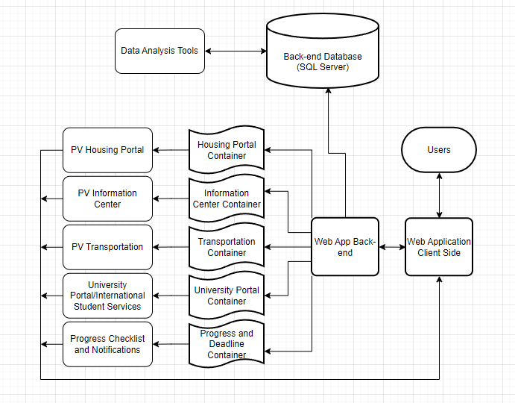

*Fig 2: System Architecture for PV Settl*

### Database Design

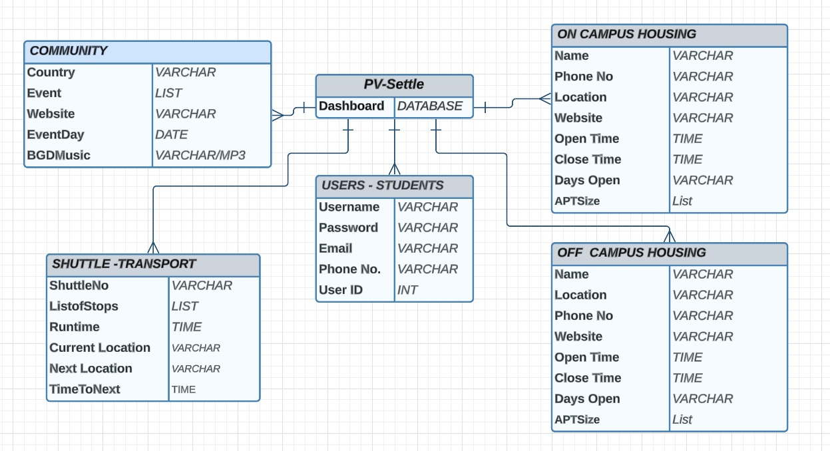

*Fig 3: Entity Relationship Diagram for PV Settle*

The PvSettle Database is the main SQL structure that holds several tables of data and information within it.

**Table 1: Students** [Username**,** Password**,** Email**,** Phone No.andUser ID (Primary Key)]

**Table 2: On campus housing** [Name**,** Phone No**,** Location**,** Website**,** Open time**,** Close time**,** Days Open**,** AptSize]

**Table 3: Off Campus housing** [Name, Phone No, Location, Website, Open time, Close time, Days Open, AptSize]

**Table 4: Shuttle Transport** [Country, Event, Website, EventDay, BgdMusic]

**Table 5: Community** [ShuttleNo**,** ListOfStops**,** Runtime**,** CurrentLocation**,** NextLocation**,** Timetonext]

### UI Design

The UI design for the PV Settle website aims to create an intuitive, user-friendly, and visually appealing platform that effectively aids international students in their transition to PVAMU.

In developing the UI, we are following web design best practices and standards outlined in sources like World Wide Web Consortium (W3C) standards to define the structure and markup of web pages. Key elements we are incorporating:

- Clean, uncluttered layout: Removing visual clutter, unnecessary text/icons, ample white space

- Intuitive navigation: Clear menu and links, logical information hierarchy, consistent layout

- Scannable content: Clear headings, bulleted lists, highlighting important info

- Friendly, inviting tone: Casual language, uplifting images, cool color palette

- Cultural awareness: Considerate of diversity, visuals reflect user base

Specifically for PV Settle, we want to create a modern, uplifting aesthetic with vibrant accent colors and images of smiling students from diverse backgrounds to make international students feel welcome. Icons will be used to enhance visual interest and comprehension.

The layout will be structured around clear main menus and navigation to help users quickly access the main hubs of the site, like Student Dashboard, Housing, Academics, Transportation, Community, and Resources.

**Guidelines and Standards**

1. Responsive Design: In line with modern web design standards, PV Settle is designed to be responsive. This means that the interface adapts seamlessly to different screen sizes and devices, ensuring a consistent and optimized experience for both desktop and mobile users.

2. Minimalistic Design: We follow a minimalist design approach, reducing clutter and distractions. This allows users to focus on essential tasks and information without being overwhelmed.

4. High-Quality Imagery: We use high-quality, relevant images to enhance the visual appeal and convey the welcoming environment of the university.

5. Content Hierarchy: Information is organized hierarchically, clearly distinguishing between different sections and features. This helps users quickly locate what they need.

6. Loading Speed: The platform is optimized for fast loading times, ensuring students can access information quickly, even with varying internet speeds.

**Branding and University Identity**

The PV Settle website aligns with Prairie View A&M University's branding guidelines to maintain a cohesive identity. This includes using the university's official colors to create a sense of affiliation and trust.

In conclusion, the UI design for PV Settle is not only aesthetically pleasing but also highly functional, with a focus on user needs and ease of use. We adhere to established web design principles and standards to ensure the platform's effectiveness and user satisfaction. The goal is an optimal, user-centric UI design to empower international students in their transition and provide seamless integration into the Prairie View A&M University community**.**

### SEQUENCE DIAGRAM

*Fig 4: Software Architecture for PV Settle*

**Chapter 6**

**Implementation Details**

This will be available for final report.

**Chapter 7**

**System Validation**

This will be available for final report.

**Chapter 8**

## Conclusion and Future Work

In conclusion, this technical report sheds light on the challenges faced by international students as they transition to Prairie View A&M University (PVAMU) and the significant impact these challenges can have on their academic and social experiences. The report introduced PV Settle, a user-friendly web application designed to address these challenges and create a supportive environment for international students.

PV Settle is an innovative solution that aims to bridge the information gap by offering valuable features, including housing options, community-building tools, and essential information for seamless integration into the PVAMU community. This application has the potential to significantly improve the lives of international students, helping students adjust to the unique environment and succeed in academic and social endeavors.

The project's goal is clear: to enhance the transition and integration experience of new international students at PVAMU. By developing a responsive web-based application wiFh a user-friendly interface, the project aims to supply a comprehensive and accessible source of information and support. It recognizes the importance of addressing the unique needs of international students and fostering a more inclusive and supportive environment.

The choice of development tools, including Visual Studio, GitHub, and programming languages like HTML, CSS, PHP, and MySQL, reflects the commitment to creating a modern, accessible, and user-centric application. This project highlights the potential for technology to enhance the international student experience at PVAMU and create a more inclusive educational environment.

For future work:

PvSettle is currently undergoing development and will receive more updates over the next few weeks. We've made tremendous progress since the day we thought of the idea and its been a very fun learning experience. We have several functioning modules with room for more for when the need arises.

several future work ideas that we have are:

Integration with the main Pvamu website

Integration of student account from Pvamu

Adding PvSettle as a page available on panthertracks

Promoting PvSettle on the International Student Services Page

Creating more modules based on user need and feedback

Adding more information about things to do around Houston

Adding a message board for users to communicate with each and get acquainted

**Bibliography**

<https://www.cpp.edu/international/students/index.shtml>

**Appendices**

Software Code for PvSettle:

Index.html

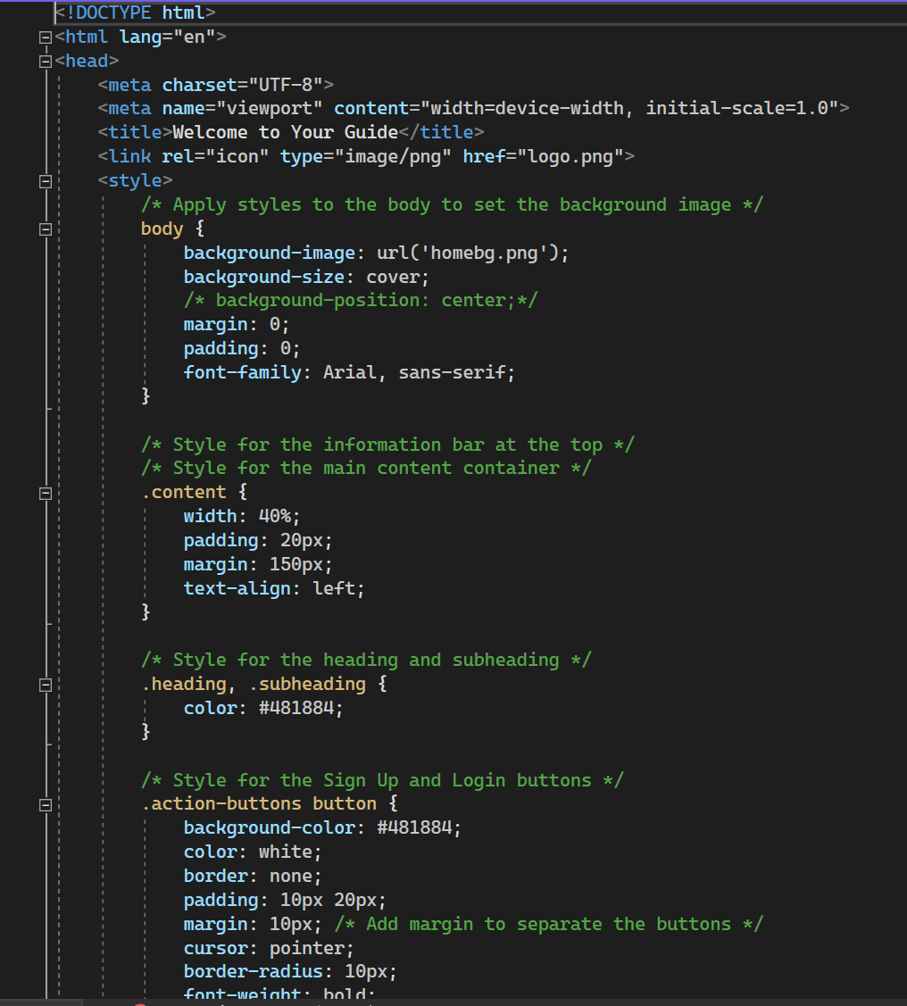

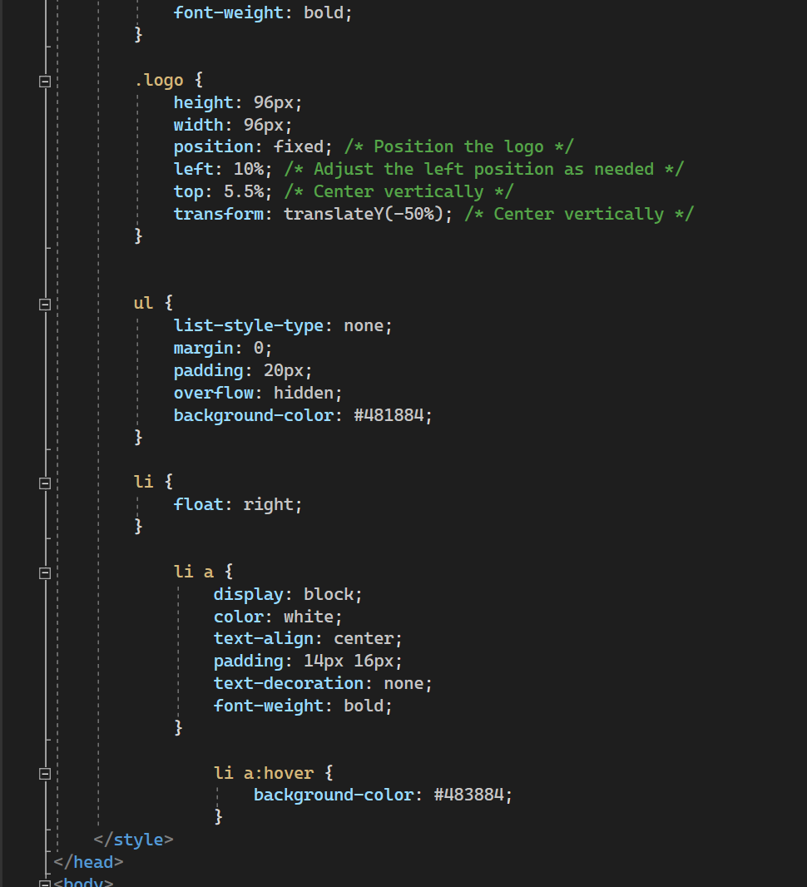

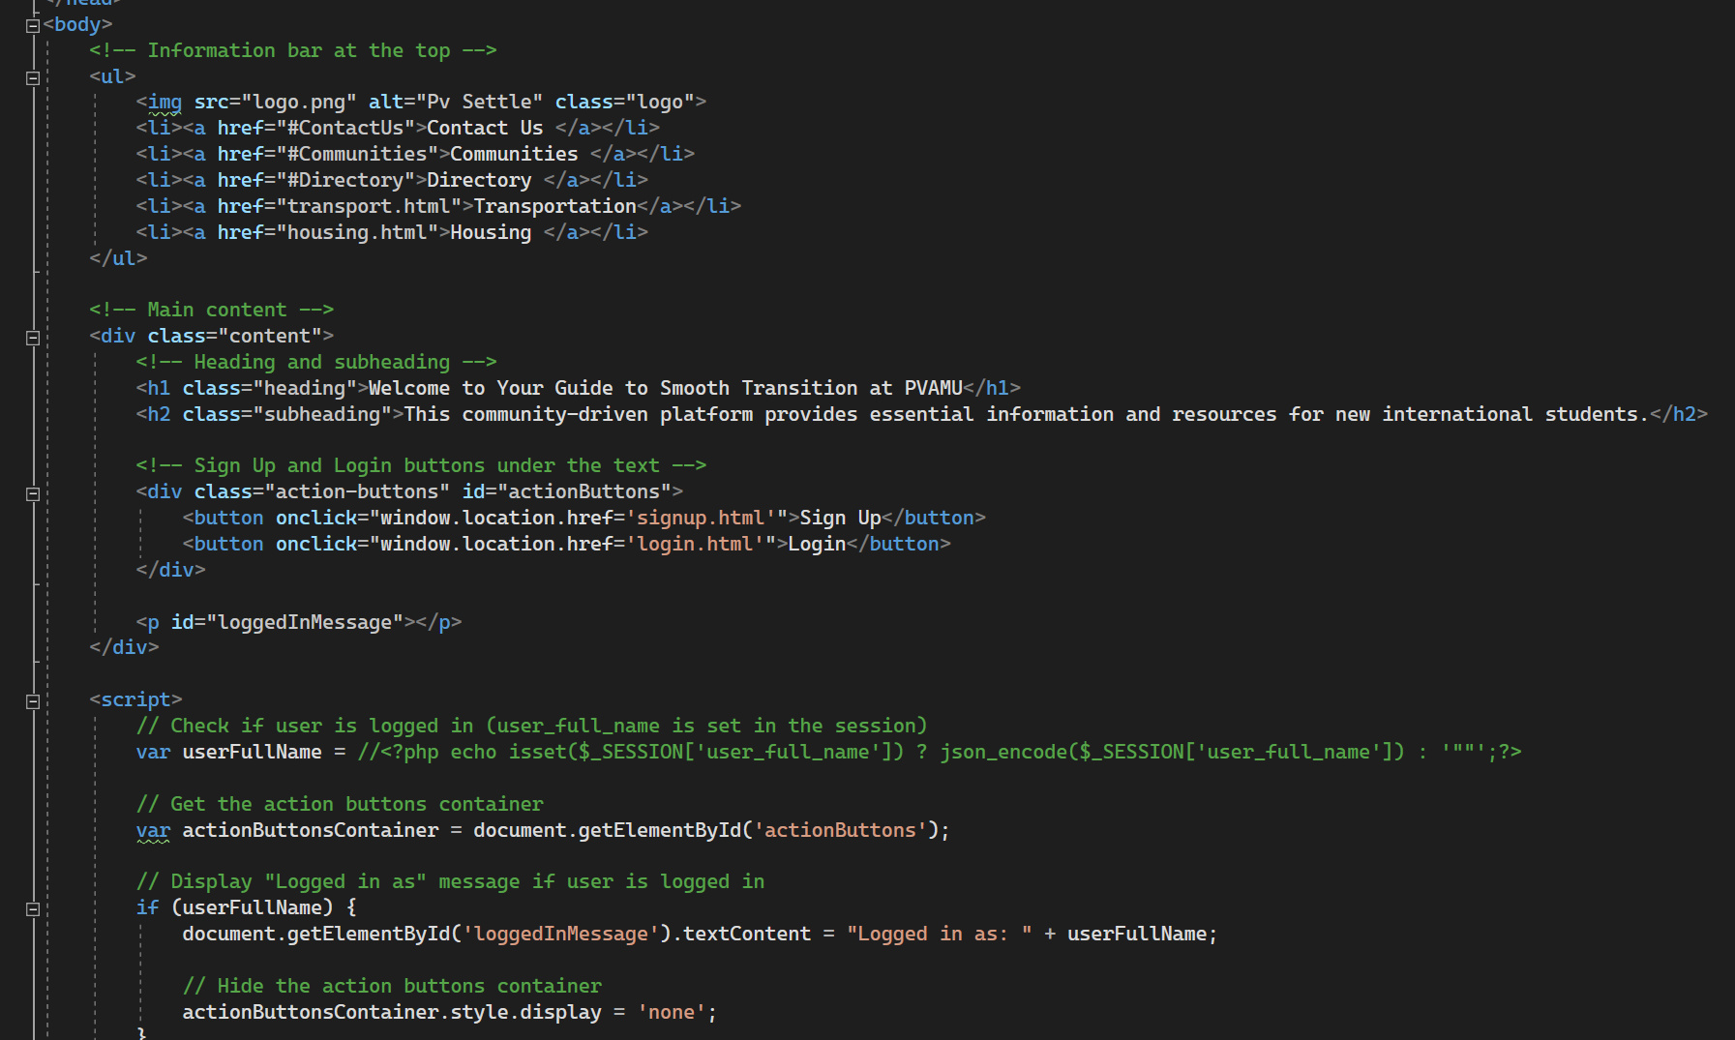

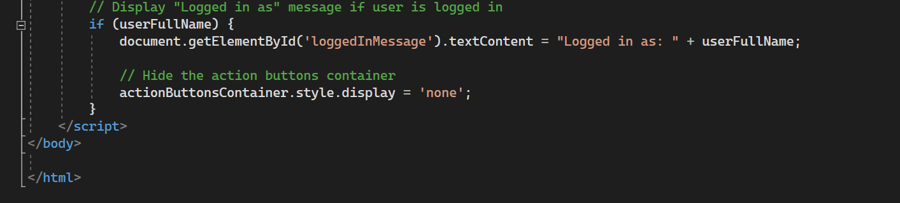

Login.html

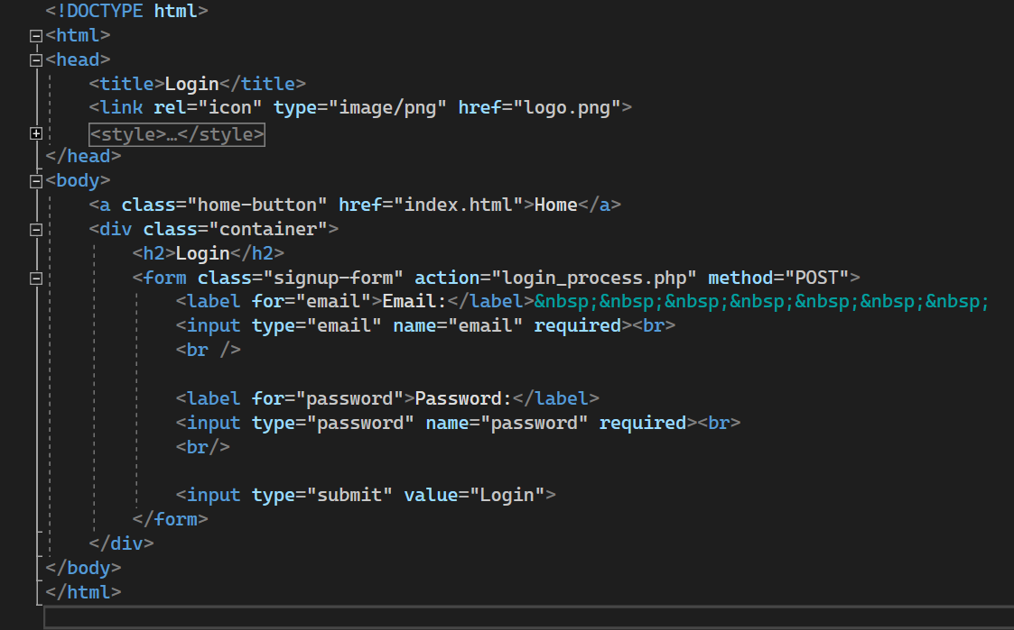

Login_process.php

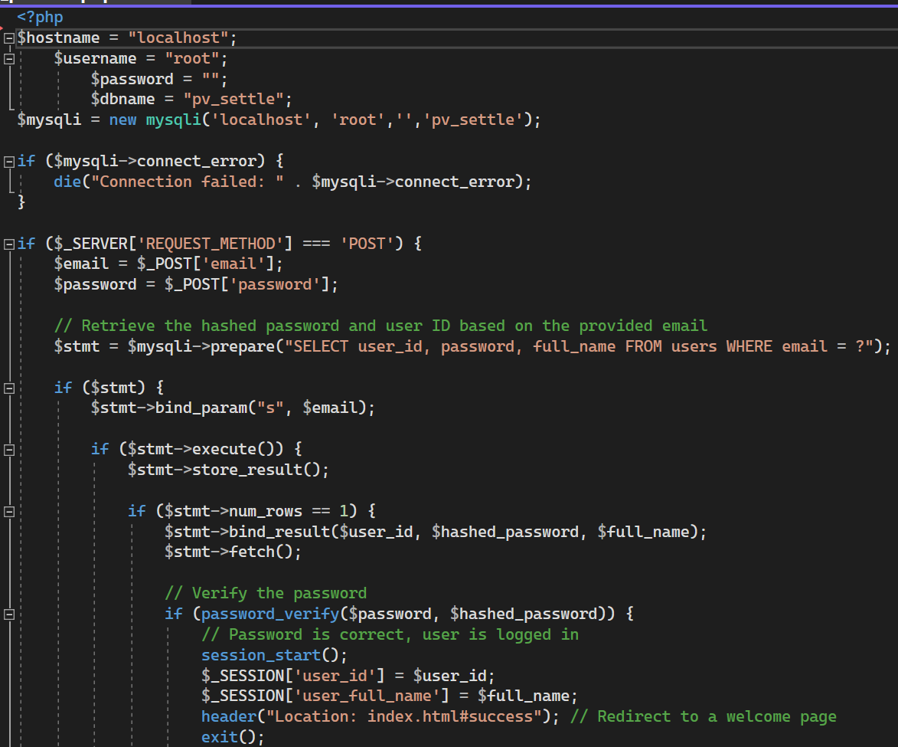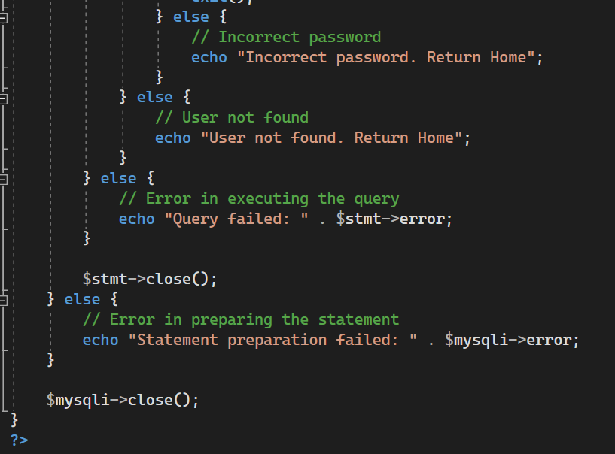

Signup.html

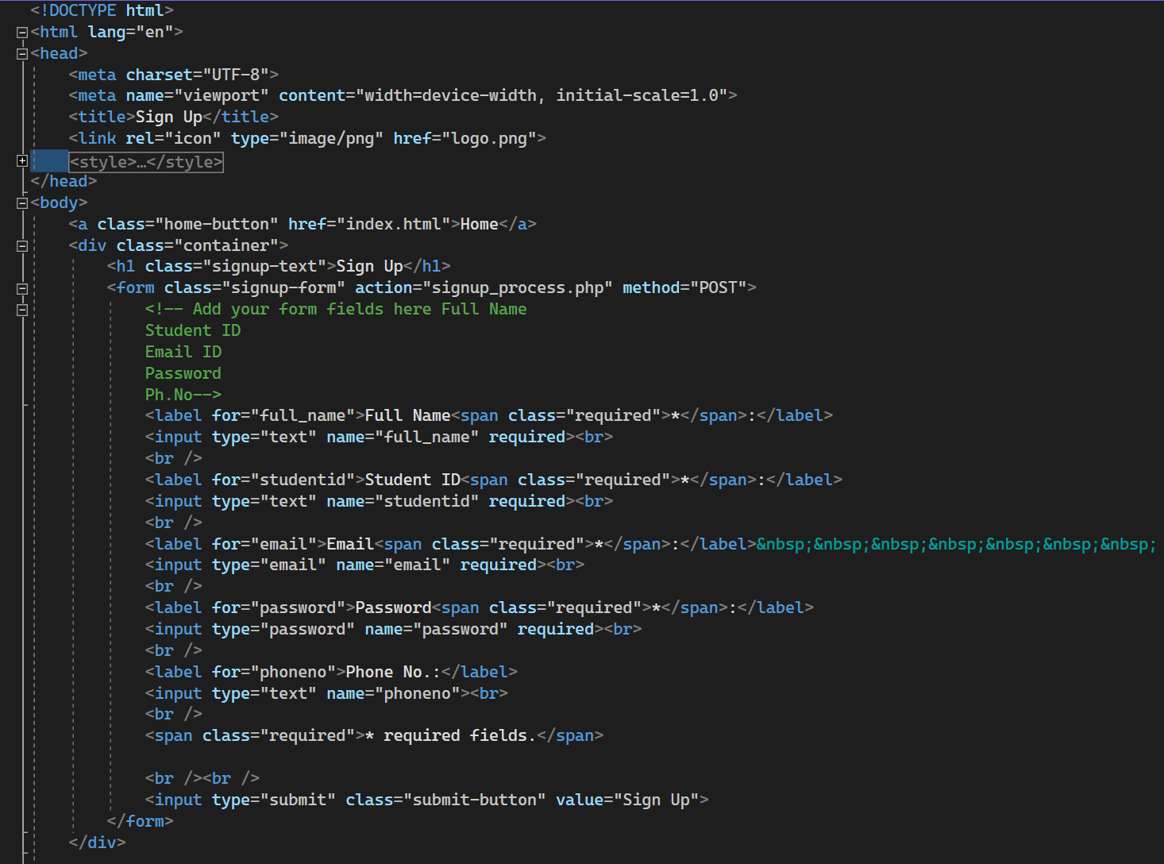

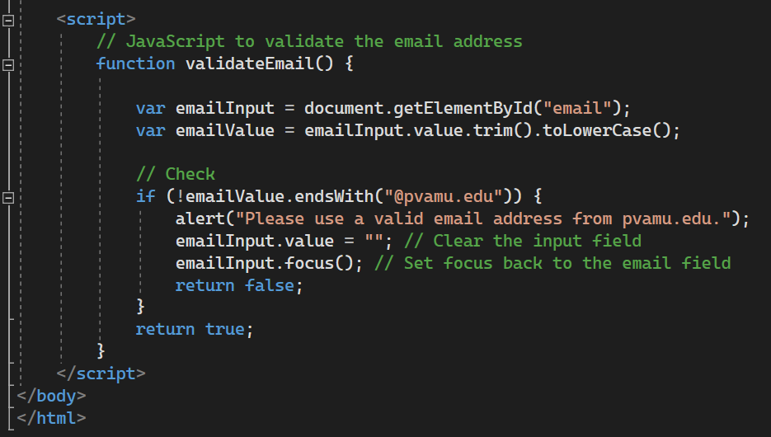

Signup_process.php

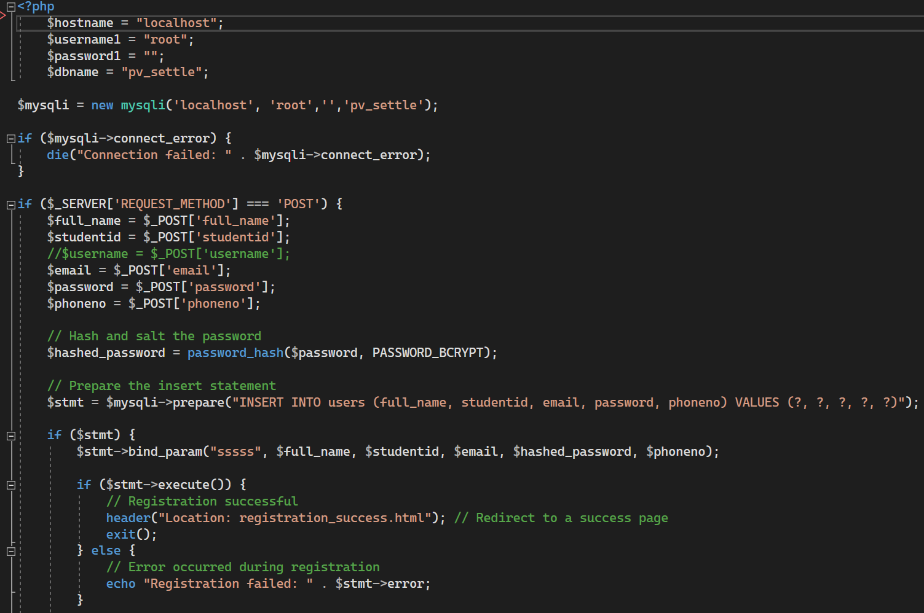

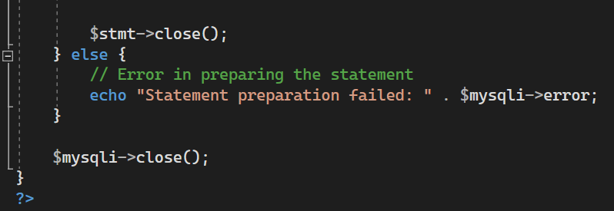

Registrationsuccess.html

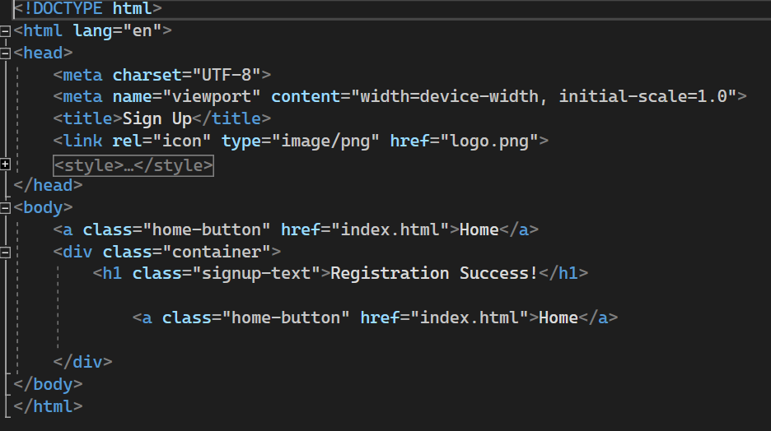Housing.html

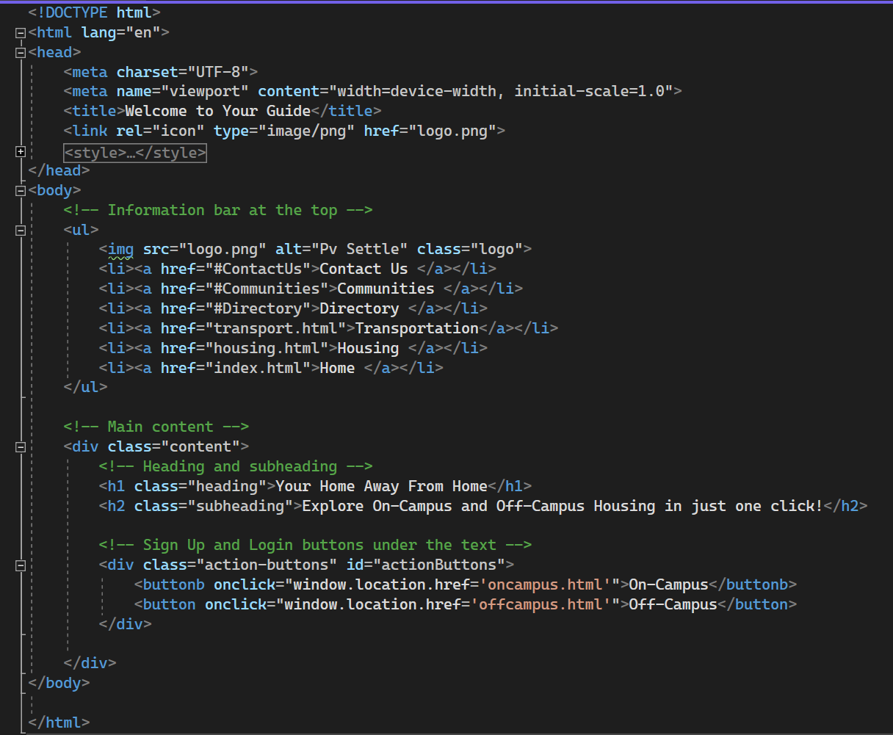

oncampus.html

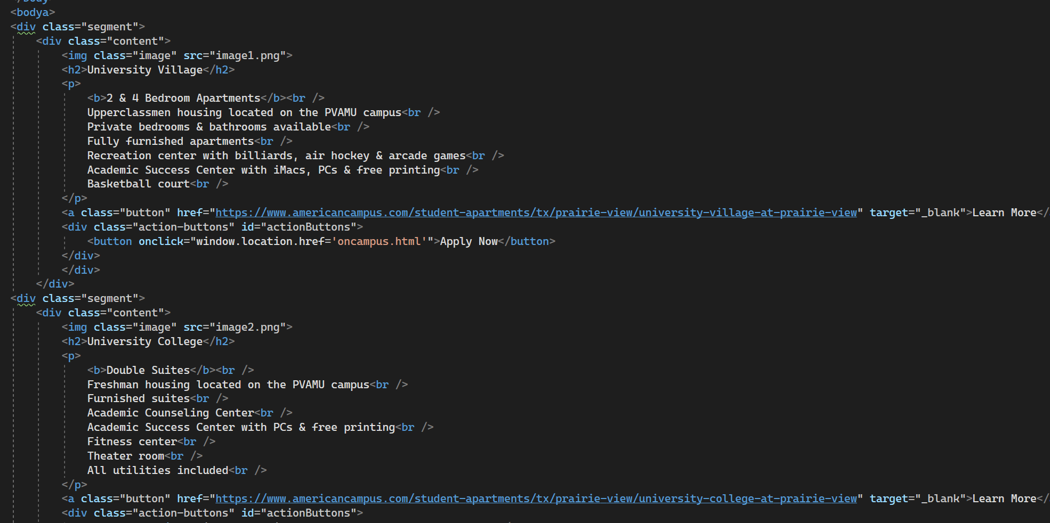

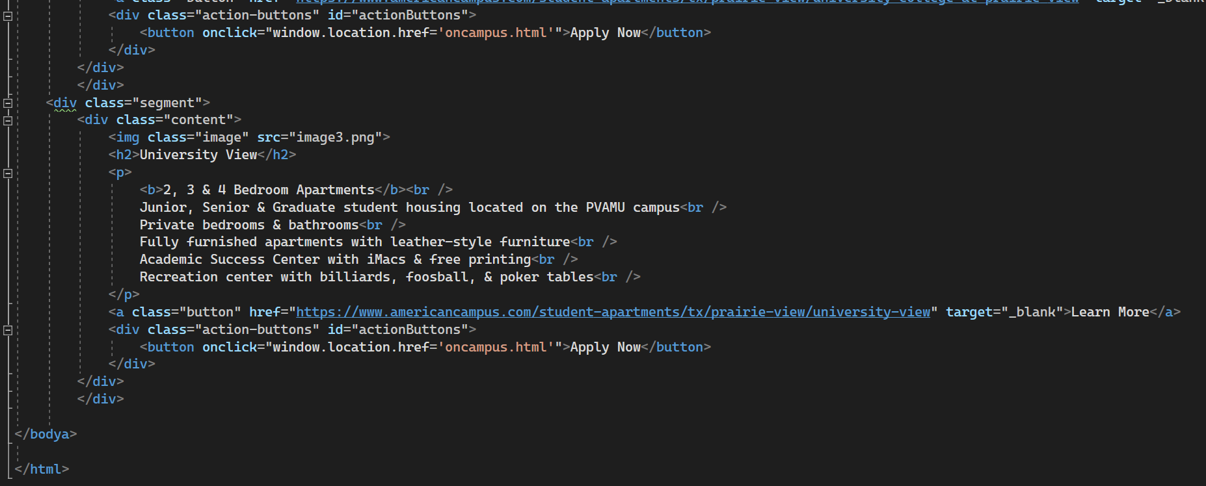

offcampus.html

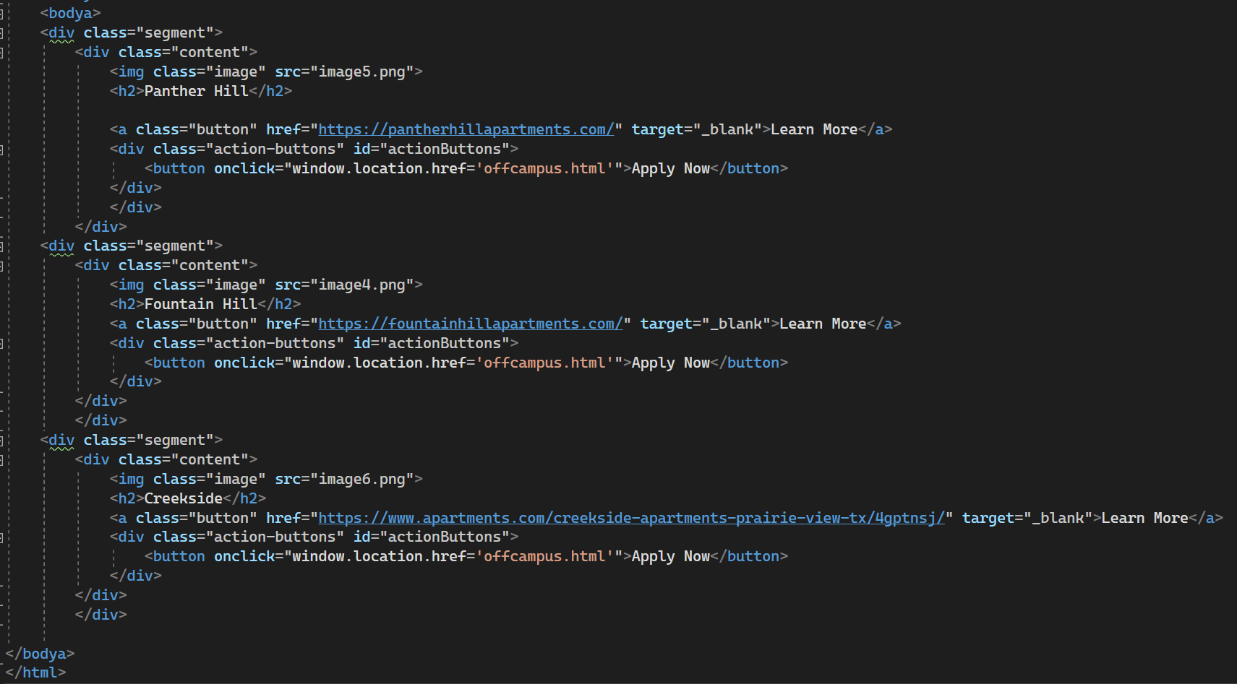

transport.html

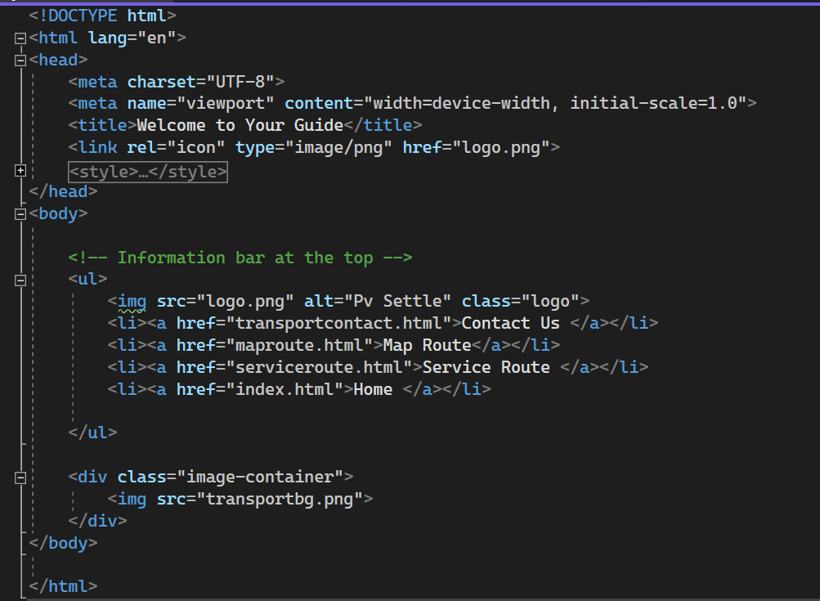

maproute.html

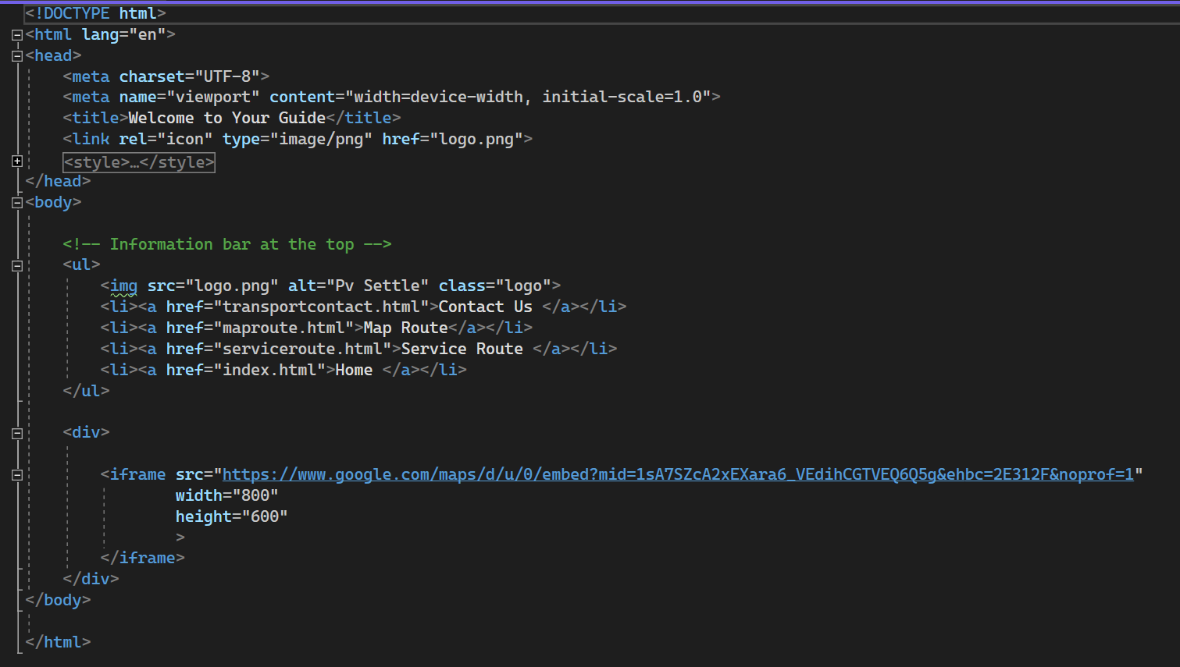

service.html

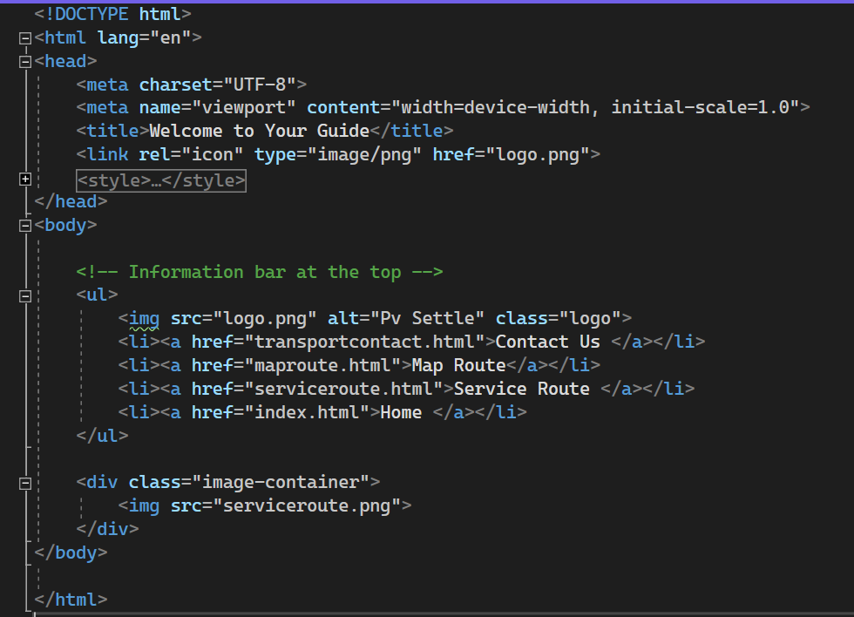

transportcontact.html

